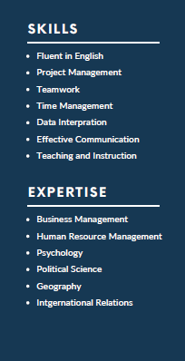
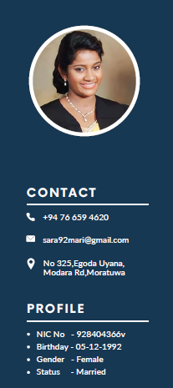
SARA SILVA
Masters’ in Business Administration (Wolverhampton, UK)
Bsc in Social Sciences (First Class) (Batch Top) (Hons) (KDU,SL)
WORK EXPIRIENCE

- Currently working as a Lecturer in Faculty of Defence and Strategic Studies at Kotelawala Defence University
- Currently working as a part time lecturer at Summerset Campus Maharagama. Under the degree programs- Business Management, Health Care Management, Tourism and Hospitality Management
- Currently working as a part time lecturer at CFPS law school.
- Worked as a Consular Officer at Consulate of Republic of Botswana in Sri Lanka (2016-2024)
Unmarried

SUMMARY

I am an enthusiastic, self-motivated, reliable, responsible and hard working person. I am a mature team worker and adoptable to all challenging situations. I am able to work well in a team environment as well as using own initiative. I am able to work well under pressure and adhere to strict deadlines. My good communication skills and presentation skills are my strengths in achieving objectives.

EDUCATIONAL QUALIFICATIONS

- Currently Reading for the PhD in Military History at Kotelawala Defence University, Ratmalana,
- Completed my Masters in Business Administration at Wolverhampton University UK.
- Completed my Bsc in Social Sciences [First class] (Batch top) from Kotelawala Defence University

History

EXTRA CURRICULAR ACTIVITIES

- Represented Sri Lanka in “Future World Leaders summit” held at Washington DC, USA 2009
- Represented Sri Lanka in “Japan-Sri Lanka Friendship Association” in year 2007
- “The Li-Ning Badminton Tournament in Singapore” in 2010
- Awarded Kotelawala Defence University Colors for Badminton (2013,2015)
- Sri Lanka Schools National colors in 2009

REFERENCES

- Mr. Mahen Kariyawasam
Consular General of Republic of Slovak
No 130, Level 1
Nawala Road,
Phone- 0777317766
Email- mahenrk@sltnet.lk

- Major General Chandana Wickramasinghe RWP RSP ndu psc MA (IR)
Commandore Security Forces (Jaffna)
Headquarters
Security Forces
Jaffna
Phone- 0766907011
Email- sfhqjaffna@army.lk

